DS LAB FILE

Name – SNEHA SIDHU
Roll no – 24/SCA/BCA(AI&ML)/065
Section – II-D
CODES
- BINARY SEARCH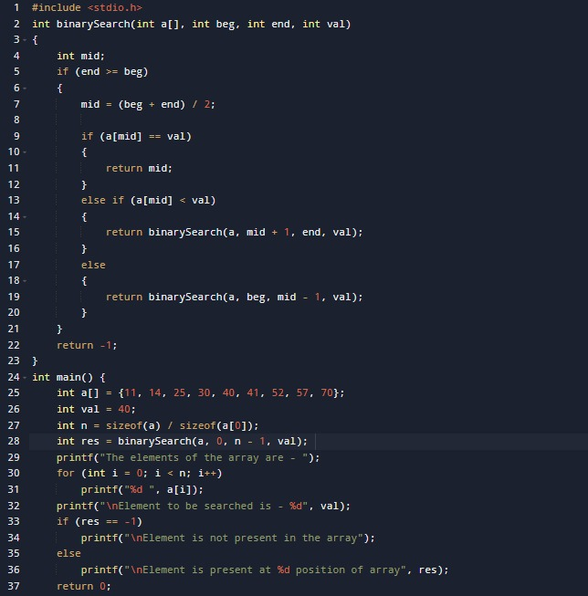
OUTPUT
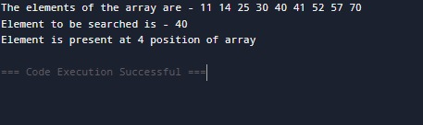

2.PASSING ARRAY TO FUNCTION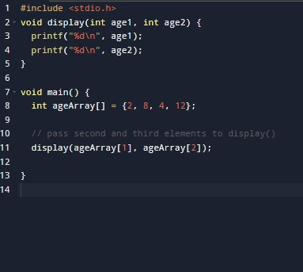

OUTPUT
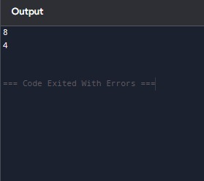
3.LINEAR SEARCH
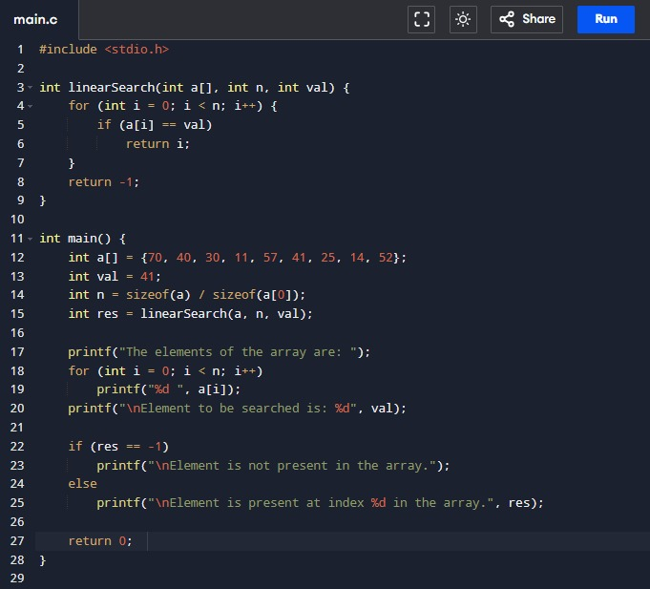
OUTPUT
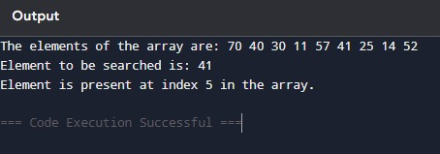
4.Sparse Matrix
OUTPUT:

5.Stack Operations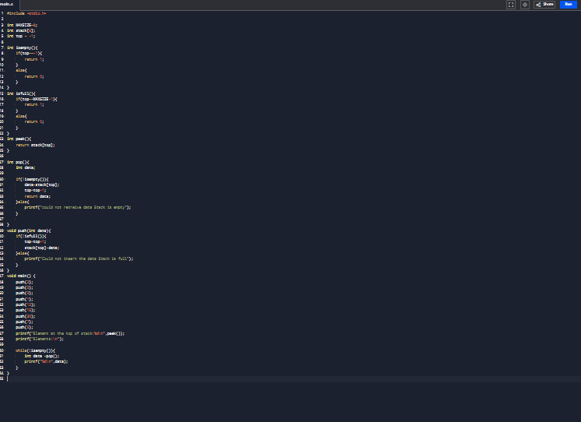
OUTPUT
